EXECUTIVE COMMITTEE OF AWRP 2017-2018
The President  Mr. Manzur Hussain (1141)  (Former Auditor General of Pakistan)  House. 90, Street. 52,  Sector I-8/3, Islamabad.  Ph; 051-4445945,  Cell: 0300-5125847, 0301-3002000 | 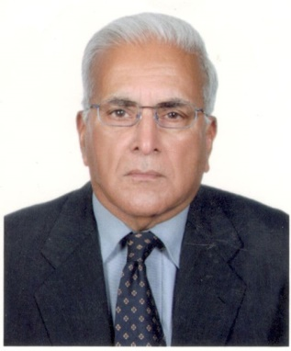
Vice President  Mr. S. Farogh Naweed (785)  (Former Federal Secretary)  House. 50, Street. 11,  Sector F-11/1, Islamabad  Ph; 051-2294142, 051-2700407,  Cell: 0300-8548944  farogh_naweed@hotmail.com | 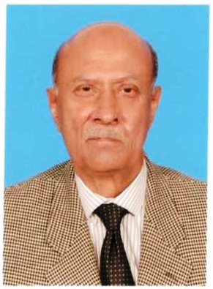
Secretary General  Mr. Ali Asghar Awan (1289)  (Former Joint Secretary, M/o Minorities Affairs)  House. 336, Street. 28,  I-8/2, Islamabad Cell: 0322-9856705  Asgharawan1943@gmail.com | 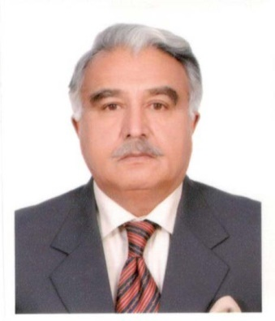
Joint Secretary  Mr. Saifullah Khan (844)  (Former Dy. Secretary, M/o Religious Affairs)  House No. 80/5-D, Street No. 32,  Sector F-6/1, Islamabad  Ph: 051- 2824134, 051-2298851  Cell: 0300-2198671 | 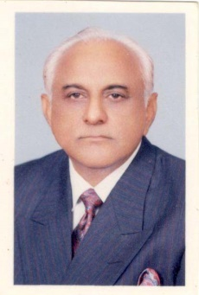
Finance Secretary  Mr. Nasim Akhter Qureshi (1033)  (Former Controller, PBC)  House No. 6/6-C, Street No. 5,  Sector G-7/2, Islamabad  Ph: 051- 2890304,  Cell: 0300-5122821  nasim_qureshi@yahoo.com | 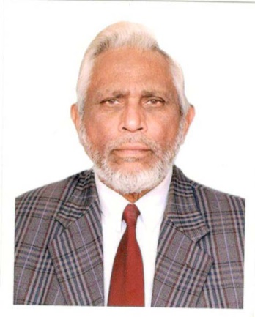
EXECUTIVE MEMBERS

Mr. Abdul Majid Qaiser (1004)  (Former Dy. Secretary, M/o Finance)  Qrt. No. 116/4-E, Service Road,  Sector G-7/2, Islamabad  Cell: 0332-5044005 | 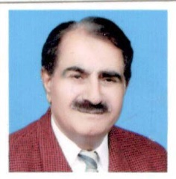
Mr. Abdul Rauf Malik (1288)  (Former Director General, M/o I&B.)  House No. 258, Street No. 62,  Sector I-8/3, Islamabad  Ph: 051-4449504,  Cell: 0305-5400052 | 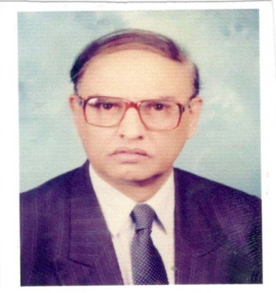
Mr. Agha Amir Ahmad (1256)  (Deputy Director, AGP)  House. 308, Street. 77,  G-9/3, Islamabad.  0300-9800246,  Amir_agha@hotmail.com | 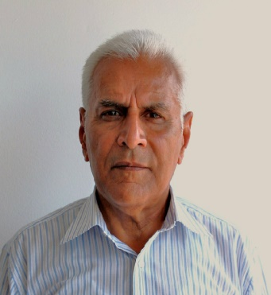
Mr. A.H. Qureshi (144)  (Former Dy. Secretary, M/o Finance)  House No. 1, Street No. 30,  Sector F-6/1, Islamabad  Ph: 051-2270830  Cell: 0333-5129760 | 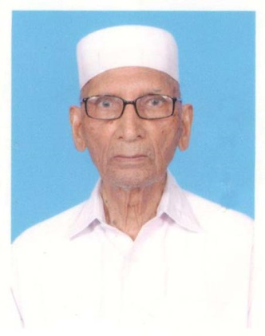
Mr. Ijaz Hussain Khawaja (975)  (Former Director General, PCB)  House No. 7-A, Park Road,  Sector F-8/1, Islamabad  Ph: 051- 9260680  Cell: 0333-5265322  ijaz@iiu.edu.pk | 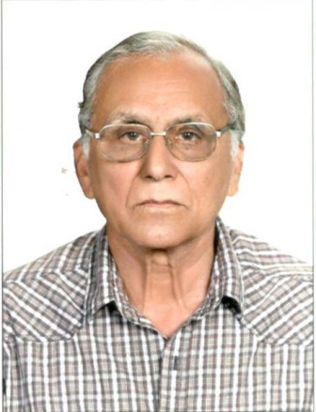
Ch. Ikram ul Haq (1010)  (Former Deputy Director , PID)  House No. 187, Street No. 9,  Sector-II, Khayaban-e-Sir Syed,  Rawalpindi.  Ph: 051-4830339 | 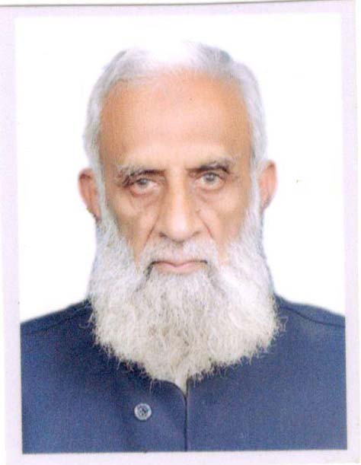
Dr. Muhammad Abdhoo (906)  (Former Consultant Surgeon, Poly Clinic)  House No. 35, Street No. 38,  Sector F-8/1, Islamabad  Cell: 0321-5009419  dr.abdhoo1@gmail.com | 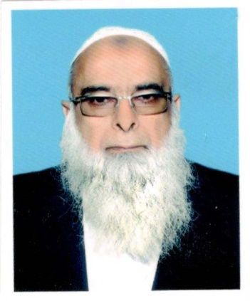
Mr. Mukhtar Ahmed Bhatti (691)  (Former Dy. Secretary (C.C), M/o Finance)  House No. 709, Gali No. 74,  Sector G-10/4, Islamabad  Ph: 051- 2302277,  Cell: 0333-5120751  Mukhtarahmedbhatti1938@gmail.com | 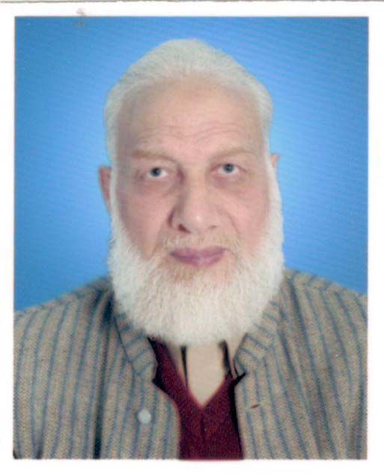
Chaudhry Munir Ahmed (1472)  (Former Director General, National Archives)  House No. 764 (f.f), Street No. 25,  Service Road West,  G-9/1 Islamabad.  (Cell: 0322-5393347) | 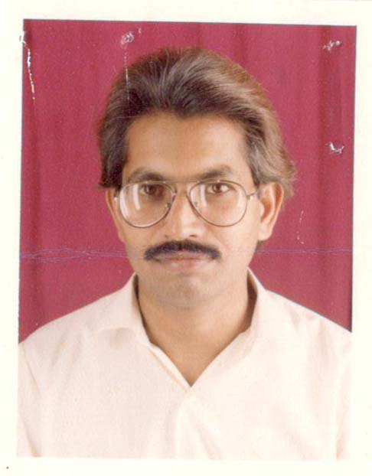
CO-0PTED MEMBER

Sardar Wali ur Rehman (1398)  (Former Superintendent, M/o Law & Justice)  House No. 185-B, Street No. 17,  G-6/2 Islamabad.  (Cell: 0345-5274065)  (Tele: 051-2337393) | 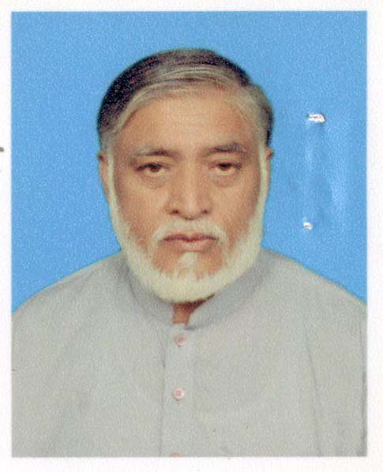
Mr. M. H. Shah (781)  (Former J.S, Ministry of labour & Manpower)  House No. 78, Street No. 6,  Sector G-8/2, ISLAMABAD  (Cell: 0303-5249914 | 