

Editor-in-Chief
Manzur Hussain
President AWRP

Editor
Tila Mohammad
Joint Secretary

Coordinator
Ainuddin Siddiqi
Secretary General

Circulation in-charge
Saeed Haroon
Office Manager AWRP

Community Center,
Ibn-e-Sina Road,
G-9/2, Islamabad
Phone: (051) 225 6282
Email: association.awrp@gmail.com
Website:
www.awrp.org.pk
No. AWRP/AGM/27/2016 dated: 30 December 2016

NOTICE

27th ANNUAL GENERAL BODY MEETING
The 27th Annual General Body meeting of AWRP, including election of the Executive Committee will be held at 10.00 AM on Saturday 21 January 2017 in the Community Centre, Ibn-e-Sina Road, G-9/2, Islamabad. Agenda of the meeting is enclosed.
All Members are requested to attend the meeting, positively.

Ainuddin Siddiqi _{FCMA}
Secretary General
All Members of AWRP

Note: Please bring your AWRP/CNIC Card with you

ANNUAL GENERAL MEETING 2015

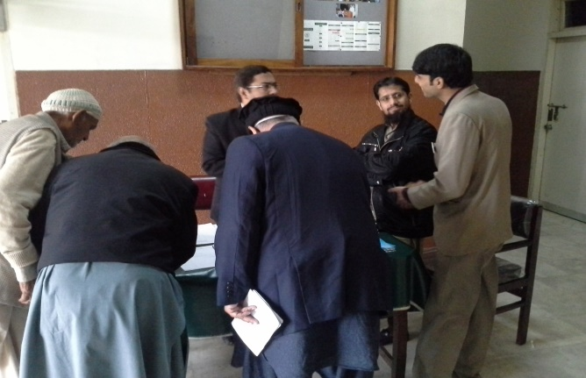 | 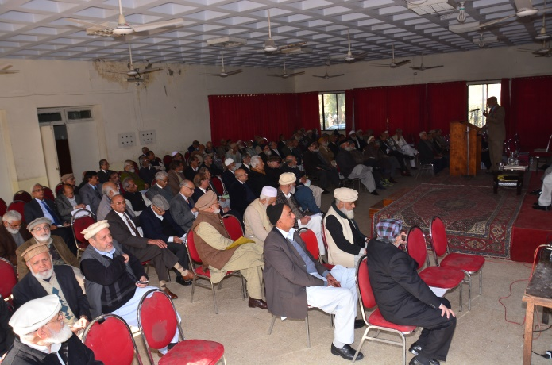
Members registering for AGM | Members attending AGM
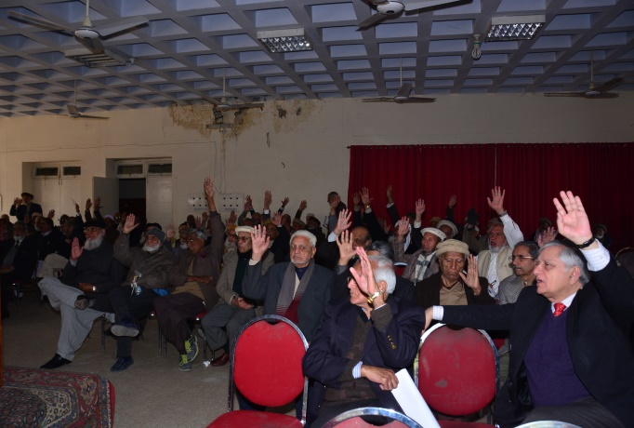 | 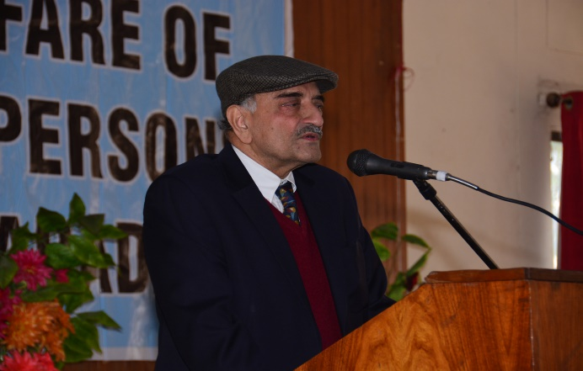
Members approving Resolution | Ex-President Mr. Parvez Ahmad Butt adressing AGM
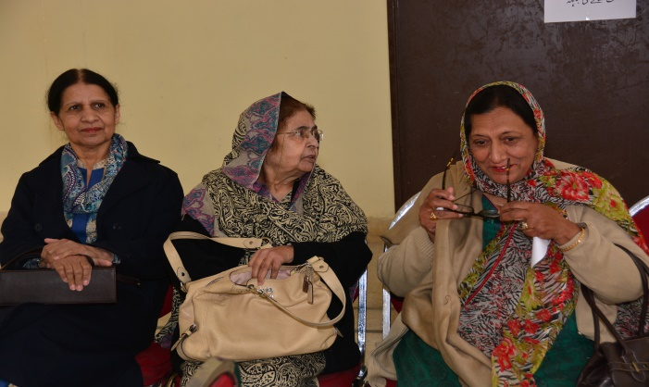 | 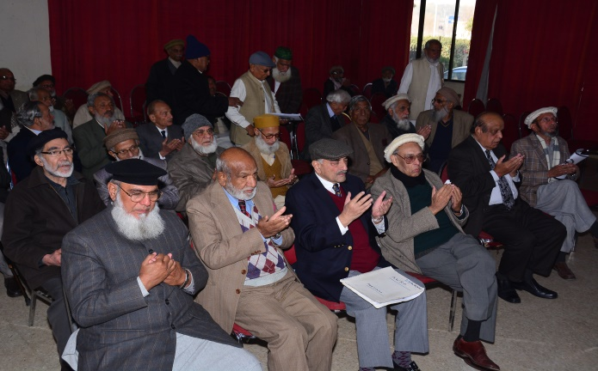
Lady Members in attendance | Members offering fatiha for the departed souls

EXECUTIVE COMMITTEE OF AWRP 2015-2016
President – Mr. Manzur Hussain (1141)  (Former Auditor General of Pakistan)  House: 90, Street: 52, Sector I-8/3, Islamabad. Ph; 051-4445945, Cell: 0300-5125847, 0301-3002000 |  | Vice President – Mr. G.A. Sabri (1164)  (Former Federal Secretary)  House: 14, St: 74, Sector: G-6/4, Islamabad.  Ph: 051-9211591, Cell: 0321-5171949  ga.sabri@gmail.com
Secretary General  Mr. Ainuddin Siddiqui (1000)  (Former Federal Secretary)  House: 38, Street: 27, Sector: F-10/1, Islamabad. Ph: 051-2105721, Cell: 03008554601, Ainuddin_siddiqi@yahoo.com.uk |  | Joint Secretary  Mr. Tila Muhammad (1119)  (Former Dy: Chief Planning Division)  House: 1379, St: 32, Sector: G-11/2, Islamabad.  Ph: 051-2317173, Cell: 0331-5090193  tila193@gmail.com
Finance Secretary C h.M.B. Arif (1202)
House No. 1141, Main double Road, Khayaban-e-Kashmir, Sector G-15/1, Islamabad.
Ph. 051-2328092, Cell: 0300-9566348
EXECUTIVE MEMBERS
Mr. M. Abdullah Yusuf (1224) (Former Secy-General & Chairman, FBR:)  House: 744, Street: 83,  Sector: I-8/4, Islamabad.  Ph: 051-4862881, Cell: 0300-5554747  Abdullahyusuf48@gmail.com | Dr. Abdul Salam (1022)  (Former Chairman, Agri: Price Commission)  House: 534, Street: 5,  Sector G-11/1, Islamabad.  Ph: 051-2105466, Cell: 0334-5235363  drsalam46@gmail.com |  | Mr. M. Amin Qureshi (1011)  (Former P:S: M/o I&B:)  House: 242, Street No: 162,  Sector: G-11/1, Islamabad.  Ph:051-2300466, Cell: 0333-5228340  qureshis242@hotmail.com
Mr: Abdul Ghafoor Mirza (1187)  (Former Federal Secretary)  House: 24, Street: 44,  Sector: F-8/1, Islamabad.  Ph: 051-9262158, Cell: 0300-9801907  ghafoormirza345@gmail.com | Mr: Muhammad Iqbal Rao (1034)  (Former Dy: Secretary, M/o Finance)  House: 23-A, Street No: 52,  Sector: E-11/3, Islamabad.  Ph:2228500, Cell: 0300-9700539  iqbalrao786@gmail.com |  | Mr: Wahid Hasan Khan (1024)  (Officer In charge Ministry of Saffron)  House: 23-A, Street: 52, Sector E-11/3, Islamabad. 051-2228500, 0321-5275339  wahidkhanpk786@gmail.com
Mrs: Aysha Mueen (1146)  (Former Associate Professor, ICG)  House: 146, Street: 99,  Sector I-8/4, Islamabad.  Ph: 051-4862050, Cell: 0300-9506431  ayeshamueen@yahoo.com | Mr: S:M Hassan Zaidi (1158)  (Former Sr: Joint Secretary)  House: 466, St: 107,  Sector: I-8/4, Islamabad.  Ph:051-4447059, Cell: 0300-5248353  hz466@live.com |  | CO-0PTED MEMBER
Dr: Sheikh Aleem Mahmud (1221)  (Former Federal Secretary)  House: 35: Street:63,  Sector: F-10/3, Islamabad.  Ph: 051-2291616 Cell: 0300-5550777  Aleem.mahmud@gmail.com | Mr: S: M: Ali Akbar (1150)  (Former Director, PID, M/o I&B)  House: 303, Street: 53,  Sector: G-10/4, Islamabad.  Ph: 051-2302601, Cell: 0300-5387490  s_shumail@yahoo.com |  | Mr: Agha Amir Ahmad(1256)  (Deputy Director PEC)  House: 308, Street: 77,  G-9/3, Islamabad.  0300-9800246,  Amir_agha@hotmail.com

Agenda
27TH ANNUAL GENERAL BODY MEETING
21 January 2017

10:00 AM Members report at the Registration Desk
10:30 AM Recitation from the Holy Quran
10:35 AM Presentation of Annual Report by the Secretary General, Mr. Ainuddin Siddiqi
- Approval of draft Minutes of 26th AGM and EOGM
- Audited Accounts of AWRP for 2015-16
- Nomination of Masoom Akhtar & Co as auditors for 2016-17
- Budget for 2017-18

10:50 AM Appointment of Mr. M. Abdullah Yusuf as the Patron of AWRP, resolution by
Mr. G.A Sabri, Vice President

11:00 AM Self-introduction by the contesting presidents (05 minutes each)
11:15 AM Close of AGM
ELECTION 2017-18
11:20 AM Briefing by the Election Officer
11:30 AM Commencement of balloting
03:00 PM Closure of Balloting
03:01PM LUNCHEON
6:00 PM Announcement of Election Results

SECRETARY GENERAL REPORT
(ACHIEVEMENTS 2015-16)

Ever since the present Executive Committee took over the administration of the Association, it has been enthusiastically pursing an aggressive agenda aimed at advancing the objectives of the Association. The Committee held its monthly meetings on regular basis to review the progress on various issues and take appropriate decisions. By the grace of Almighty Allah, the Committee has been able to accomplish a number of important milestones during the last two years. The Committee continued to follow up action on its proposals and requests at various levels and worked towards their positive outcome. We are glad to report that many of our requests met with satisfactory success; thereby contributing to the welfare of the retired community.
Some of the salient achievements realized so far are summarized below:
- INCREASE IN PENSION: The AWRP had been constantly requesting the Government for yearly increases in the pensions commensurate with the ever rising cost of living. The main focus of our efforts was to receive the same rate of increase in the pensions as is given to the serving Government employees. Accordingly, pensions during the last two years were increased at 10 and 7.5 percent in 2015 and 2016, respectively. Besides, pensioners aged 85 years and above were given special increase of 25 percent in their pensions, effective 01 July 2016.

Although somewhat satisfying, the principle adopted for the increase lead to cases of anomalies in the pensions admissible before and after the revisions of pay-scales of the serving employees for the years 2015 and 2016. The Association therefore took up the matter with the relevant authorities for redress. So far, only one meeting of the Anomaly Committee was held wherein, while considering the anomaly for the year 2015, the standpoint of the AWRP was accepted. On the recommendations of the Anomaly Committee, the matter has since been referred to the AGPR and MAG for assessing the financial impact. We expect early amends in the matter. We also hope that the case for the year 2016 will be placed before the Anomaly Committee in its next meeting.

Similarly, two other anomalies surfaced during the past two years regarding Medical Allowance for the pensioners due to three different definitions of the term ”net pension” applying to:

- The retirees up to 30.06.2015,
- Those having retired between 1.7.2015 and 30.6.2016, and
- Those having retired on and after 1.7.2016.

This issue is also expected to be placed before the Anomaly Committee in its upcoming meeting and hopefully resolved to our satisfaction.

- HIGHER INCREASE FOR RELATIVELY AGED PENSIONERS: Pensioners at advanced stage of life are relatively more prone to age related physical infirmities necessitating extra expenditures on medicines and related items. Hence, they require an extra penny to pay for their special needs. We are happy that acceding to our demand, the government announced a special increase of 25 percent for the pensioners aged 85 years and above in the budget 2016-17. We have, however, urged the government to reduce the threshold of 85 to 75 years for admissibility of this special increase so that the small number of pensioners alive at these years could benefit from this facility.

- INCREASE IN MEDICAL ALLOWANCE: The Association has been persistently requesting the government as not only to defreeze but also index the Medical Allowance with age so that relatively aged pensioners receive higher amount of Medical Allowance. It is satisfying that an across the board increase of 25 percent on the frozen level of 30.06.2011 was realized w.e.f, 01 July 2015.

- RESTORATION OF COMMUTATION: Restoration of commutation to the post 2001 retirees was a pressing demand of the affected pensioners. The present Executive Committee therefore took up this issue on priority basis and pleaded with the government to reverse the decision. It is gratifying that our efforts met with success and resultantly the post-2001 retirees became eligible for restoration of their commuted amounts.

- FAMILY PENSION: The Current Executive Committee gave its special attention to the problems being faced by the Family pensioners and pursued their redressal with the relevant authorities. Our primary objective was to persuade the government to extend the facility of family pension to unmarried and divorced daughters of the pensioners, besides equating the family pension to 100 percent so that surviving family members do not suffer financial loss due to death of principal pensioners. Moreover, since the formula for calculating the Family Pension was found erroneous, we pointed out the basic error in the formula to the Finance Division for correction. While interim relief has been received, we expect permanent solution of the issue in the near future.

- INCREASE IN SPECIAL ADDITIONAL PENSION: The formal request by the AWRP to increase the Special Additional Pension, based on Orderly Allowance, from Rs. 7,000 to 12,000 per month for the BPS 20 and above retirees was granted by the government, which has amply supplemented the pensions of the benefiting employees.

- AMENDMENT OF THE AWRP CONSTITUTION: The AWRP constitution was initially approved by the General Body on18.12.1989 and endorsed by the VSWA on 03.02.1990. Thereafter, various amendments had been incorporated from time to time, which were never submitted to the Voluntary Social Welfare Agency (VSWA) for authentication; hence these lacked legal validity. The present Executive Committee therefore undertook to rectify the situation by incorporating the previous amendments and making a few adjustments so that the Constitution is in conformity with the VSWA, was printed, which is available at the AWRP office for reference and supply to interested members at a token payment of Rs. 50.00 only.
- REDUCTION IN MEMBERSHIP FEE: In order to stream line the membership procedure, the system of Annual Membership was abandoned and all the Annual Members converted as Life Members without any additional fee. Moreover, to enlarge the membership base, the membership fee was rationalized as Rs. 100 hundred for BPS 1-16, Rs 500 for BPS 17-19 and Rs. 1100 for BPS 20 and above from the flat rate of Rs.2000, charged previously. This has yielded encouraging results as 160 new Members enrolled during the last two years. In addition the following steps were taken to facilitate participation of the members in the affairs of the Association.

  - Removal of restriction to contest election and cast vote: Previously, Members with less than one year membership were forbidden to contest election, nominate or second contesting candidates and cast vote in AGMs etc. This restriction was removed to allow relatively younger Members to contest election and work on the Executive Body.

  - Membership relaxed for serving Government Servants: Serving Government servants have been facilitated to register as Associate Members two years prior to their date of superannuation.

  - Right of vote to co-opted EC Members: Co-opted EC Members were granted the right to cast vote at the EC meetings through a resolution unanimously endorsed by the General Body in the 25th AGM.
- SIMPLIFICATION OF PENSION PROCEDURE. (WAFAQI MOHTASIB COMMITTEE): The Wafaqi Mohtasib had constituted various committees to develop workable recommendations for the simplification of pension procedures and pension related problems. The Association for the Welfare of Retired Persons sought representations on these committees and forwarded various recommendations, which were duly incorporated in their reports. It is hoped that positive improvements in the pension procedure will result in the light of these recommendations.
- COLLABORATION WITH SENIOR CITIZEN FOUNDATION: In order to advance the cause of senior citizens, the AWRP has entered into meaningful contact with the Senior Citizen Foundation as many of the areas of interest to both the organizations are of common nature.
- COLLABORATION WITH NAZRIYA PAKISTAN COUNCIL: In order to broaden the support base for the activities of AWRP, efforts were made to enter into fruitful collaboration with sister organizations. A collaborative arrangement has therefore been established with the Nazriya Pakistan Council for undertaking joint activities of common interest. Late Mr. Zahid Malik, ex-Chairman/Patron in Chief of the Council and a Member of AWRP, had been taking keen interest in promoting the objectives of AWRP through joint ventures in areas of common interest.

- CULTURAL PROGRAMMES: In order to provide opportunities of social interaction and entertainment, the present Executive Committee organized four “get to-gathers” during the last two years. Special donations were solicited from M/s Allied Bank Ltd., Best-Way Cement Ltd. and Pakistan Mineral Development Corporation to finance these events. Due to stringent economy in the expenditures on these functions, there also occurred some savings, which were credited to the AWRP account and reserved for similar activities in future. The functions were attended by a large number of Members along with their families and friends, who appreciated such an entertaining initiative by the present EC and provided encouraging feedback.

- CONSTITUTION OF SUB-COMMITTEES: Four Sub-Committees (i) Health Care, (ii) Culture, (iii) Welfare and (iv) Pensioners’ Grievances comprising of 04 to 05 Members each were constituted to assist the Executive Committee in the respective areas. These Sub-Committees have been vigorously working towards accomplishing their objectives. In this connection, the Sub-Committee on Health Care is of special mention, which has enrolled a number of private hospitals, Labs and Clinics to extend medical facilities to our Members on special discounts:
  - Concessional Facilities by various Hospitals/Labs Etc: Many of the renowned hospitals and medical labs located in Islamabad were persuaded to extend medical services to the Association for the Welfare of Retired Persons members on cessions ranging between 15 to 30 percent.
  - Free Medical Camps: Free medical check-ups were arranged through various renowned hospitals and Labs at the Family Dinner for the benefit of the Members. Their services were availed by a large number of Members.

- NATIONAL COUNCIL FOR SOCIAL WELFARE: The AWRP was consulted by the National Council for Social Welfare, Capital Administration Division, Government of Pakistan, in the submission/preparation of the Senior Citizen Bill and other related matters. It is likely that the AWRP will be included as a Member in the proposed Senior Citizen Council.
- PENSION BENEFIT ACCOUNT AND BEHBOOD CERTIFICATES: The present Executive Committee has been urging the government to raise the deposit limits of the Pension Benefit Account and Behbood Certificates schemes to Rs. Five million each. This has since been done by the government in the budget 2016-17. We are also trying for increasing in the rate of return on investment these schemes.

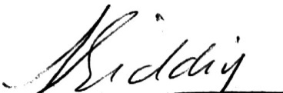
Ainuddin Siddiqi _{FCMA}
Secretary General

DRAFT
MINUTES OF THE 26th ANNUAL GENENRAL BODY MEETING
OF THE ASSOCIATION FOR THE WELFARE OF RETIRED PERSONS (AWRP)

The 26th Annual General Body Meeting of the AWRP was held on 30 January 2016 at 11 AM in the Community Centre G-9/2 under the chairmanship of Mr. Manzur Hussain, President, AWRP. About 125 Members of the AWRP attended the meeting. Mr. M. Amin Qureshi, EC Member, performed as the stage secretary.

- The meeting started with recitation from the holy Quran by Hafiz Noor Muhammad, a Member of AWRP. Fatiha was offered for all those Members who had parted with us since the last AGM. Prayers were also said for early recovery of the Members lying ill.

- Welcome Address: Mr. Ainuddin Siddiqi, Secretary General, welcomed the Members and thanked them for attending the Meeting in such a large number. He presented the Annual Report, which underlined the salient achievements of the Association during 2015. Thereafter, he submitted the following items, which were unanimously approved by the House.

      - Draft Minutes of 25th AGM and EOGM.
      - Audit Report of AWRP for 2014-15
      - Nomination of Masoom Akhtar & Co as auditors for 2015-16
      - Budget for 2016-17.

- Resolution on the right of vote to Co-opted Members: Mr. G.A. Sabri, Vice President, moved a resolution which sought the right of vote to Co-opted Members. This was unanimously passed in the AGM.

- Comments by the Members: After the passage of the above Resolution, the President invited the Members to express their views on the working of the Association. A gist of the comments of the Members is given below:

  - Mr. Muhammad Raza Sabir, Member, enquired about the difference between the last year and current year figures in respect of sponsorship, liabilities and entertainment items given in the audit report, which the Secretary General explained to his satisfaction.
  - Mr. Mukhtar Ahmad Bhatti, Member, wondered as to why the name of Mr. Wahid Hasan Khan appeared on the list of the Executive Committee instead of Syed Shahid Ahmad who was duly elected as EC Member. It was replied that Mr. Wahid Hasan Khan was inducted upon resignation by Syed Shahid Ahmad in accordance with provisions of the Constitution.
  - Mr. Bashir Ahmad Awan, Member, advised that the Members having reservation or asking clarifications right at the meeting should have sent their queries well in advance so that appropriate replies could have been prepared for their satisfaction. In his view, it was rather embarrassing for the management to answer surprise questions. The Members agreed to follow his suggestion in future.
Mr. Bashir Ahmad Awan lauded the dedication, efforts, and achievements of the Members of the Executive Committee, and said that he was happy to note that the present Executive Body had rejuvenated the Association after a long period of dormancy. He congratulated the current EC on the remarkable achievements, specifically;
- Approval of the Constitutional amendments by the Voluntary Social Welfare Agencies (VSWA) and
- Defreezing of the Medical Allowance
Mr. Bashir Ahmad Awan, however, expressed his reservations on the Direct Credit System (DCS) introduced by the AGPR and proposed that the old system should also continue for those pensioners who did not opt for the DCS.
  - Hafiz Noor Muhammad, Member, said that the restoration of commutation, presently allowed after 12 years of retirement, has been astonishingly stopped by the AGPR and desired that this issue be taken up by the Association.

- Concluding remarks by the President: Mr. Manzur Hussain, President, AWRP, thanked the Members for attending the AGM and taking keen interest in the affairs of the Association. He said that it was our endeavour to administer the affairs of the Association in a transparent manner and keep the Members abreast with various developments from time to time. He told that it was also our moral duty to bring the problems being faced by the Members into the notice of relevant authorities for redress. He expressed satisfaction on the performance of the Executive Committee and appreciated the commitment with which every Member was working towards the fulfilment of the objectives of the Association. He particularly mentioned Mr. Tila Muhammad, Joint Secretary, and M. Amin Qureshi, EC Member, who have been rendering extraordinary services to the Association. Mr. Manzur Hussain spelled out the key achievements of the current Executive Body during the year 2015, and said that it was due to the active support and encouragement of the Members that the elected Body was able to make major headways on key issues the retired community was confronting.

  - Austerity in expenditure: Mr. Manzur Hussain said that austerity has been our prime objective as for as the funds of the Association were concerned. We have been trying our utmost to conserve the funds of the Association and have successfully collected funds for various functions through donations. He referred to the two Family functions and said that these were entirely financed by outside sponsors through the courtesy of Mr. M. Abdullah Yusuf, EC Member. He also informed that in fact about Rs. 200,000 were saved out of the sponsorship funds and deposited into the Association account as a reserve fund for similar activities in future. The house enthusiastically admired this achievement.

  - Restoration of commutation: Mr. Manzur Hussain exclaimed that although the AGPR extended the restoration to about 150 persons but ironically stopped it under instructions from the Ministry of Finance. He explained that while the restoration to pre-2001 retirees was allowed by the Supreme Court, it was given under an executive order to the post-2001 retirees. Therefore, in view of the officials of the Ministry of Finance, the executive order did not enjoy the same status as that of an order of the Supreme Court. Mr. Manzur Hussain, however, hoped that this issue being under active consideration of the Finance Minister would be favourably decided.
  - Family Pension: Mr. Manzur Hussain apprised the Members on the efforts being made by the Association for raising the family Pension to 100 percent. He said that our suggestion has been accepted in principle and a positive decision was expected on this issue. He opined that he did not see any reason for the Government not to raise the Family Pension to 100 percent. Mr. Manzur Hussain also referred to the erroneous computation of Family Pension by the AGPR and said that we have raised this issue with the Ministry of Finance and were expecting a positive decision in this respect.
  - Indain Example: Mr. Manzur Hussain mentioned some examples of the Indian pension system and said that he would be placing these before the Ministry of Finance for consideration.
  - Pensioners Benefit Account (PBA): Mr. Manzur Hussain said that the rate of profit on the PBA was constantly being reduced to the disadvantage of the pensioners. He said that he would request the Government not to reduce the profit on PBA and revert it to the previous higher rate. He said that we would also request the Banks to extend various facilities to the pensioners.
  - Pension Accounting Office: Mr. Manzur Hussain said that he would be requesting the Government to establish separate and dedicated Accounting Office(s) to look after the work relating pension matters.
  - Senior Citizen Law: Mr. Manzur Hussain referred to the Senior Citizen Law and said that while the KPK Government had promulgated this law in 2014, the Federal Government was rather indifferent to this issue. He said the current EC was trying to get this Law passed at the Federal level, which would greatly benefit the aged segment of the population. He said that we were working together on this matter with the Ex-Servicemen Association and the Senior Citizen Foundation.
  - Wafaqi Mohtasib Committee: Mr. Manzur Hussain referred to the representation of AWRP on the said Committee and said that the Mohtasib Committee would include our suggestions in its report to the Government.
  - Direct Credit system (DCS): Mr. Manzur Hussain informed the Members that clarification has been obtained from the AGPR on various issues relating the DCS, which has already been circulated to the Members. However, if the Member were facing any difficulty in this respect, they may seek assistance from the AWRP.

In the end, Mr. Manzur Hussain once again thanked all the Members and requested the Members to extend support to the Executive Committee to provide it the necessary impetus for making still greater strides. He concluded his remarks by reciting the following verse by the poet Ghalib.
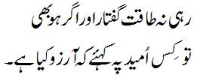

- Vote of Thanks: Mr. M. Amin Qureshi, while proposing a vote of thanks on behalf of the Association, appreciated the active co-operation of the Social Welfare Organization (SWO), particularly by Mr. Ishtiaq Ahmad, Chief Welfare Officer, G-9/2, Community Centre, for extending support and providing various facilities to the serving and retired Federal Government servants.
He also thanked the Nazriya Pakistan Council, especially, Mr. Zahid Malik, Chairman, for their cooperation and initiating collaborative projects with the AWRP for the benefit of its Members.
Mr. Amin Qureshi thanked various sponsors particularly Allied Bank Limited, Bestway Cement and Pakistan Mineral Development Corporation (PMDC) for making generous donations towards meeting the expenses of the two Family Get-together functions.
Mr. Amin Qureshi also thanked various Hospitals and Labs which have extended good concessions on their services to the Members of AWRP.
He also thanked the staff, friends and Members of the Association for extending support in organizing various functions and in the arrangements of the AGM.

- The meeting concluded with a vote of thanks to Chair.

Ainuddin Siddiqi _{FCMA}
Secretary General

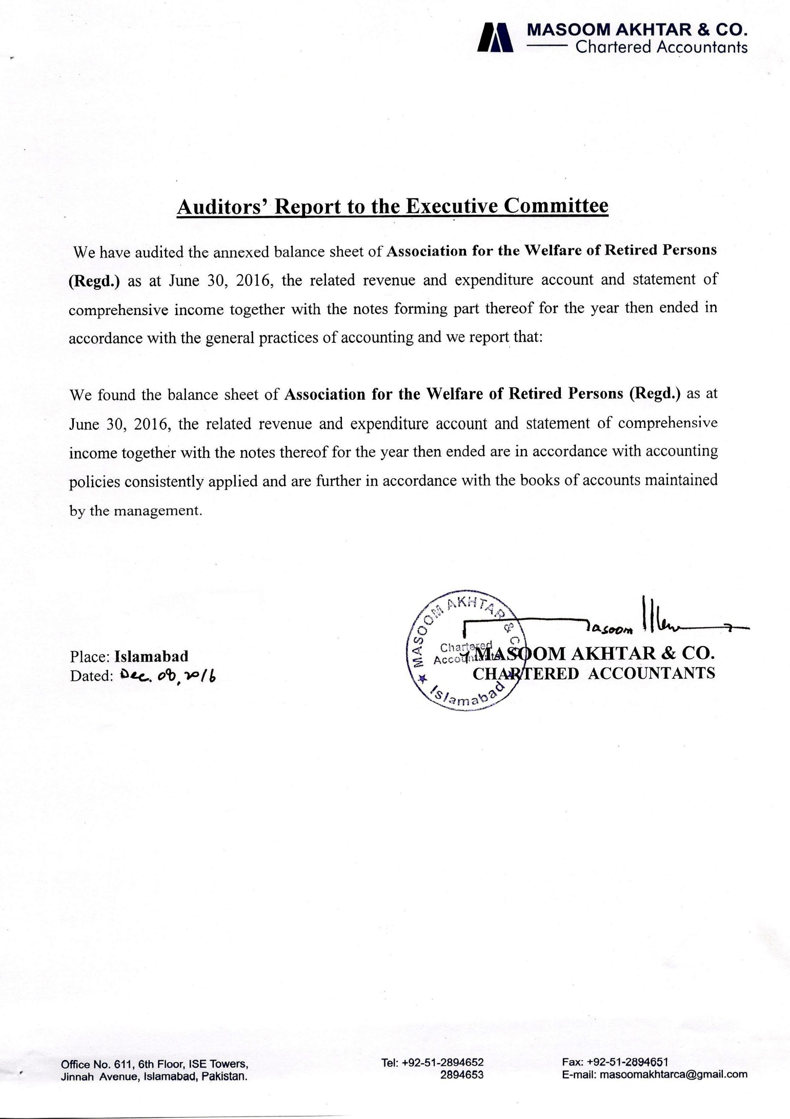

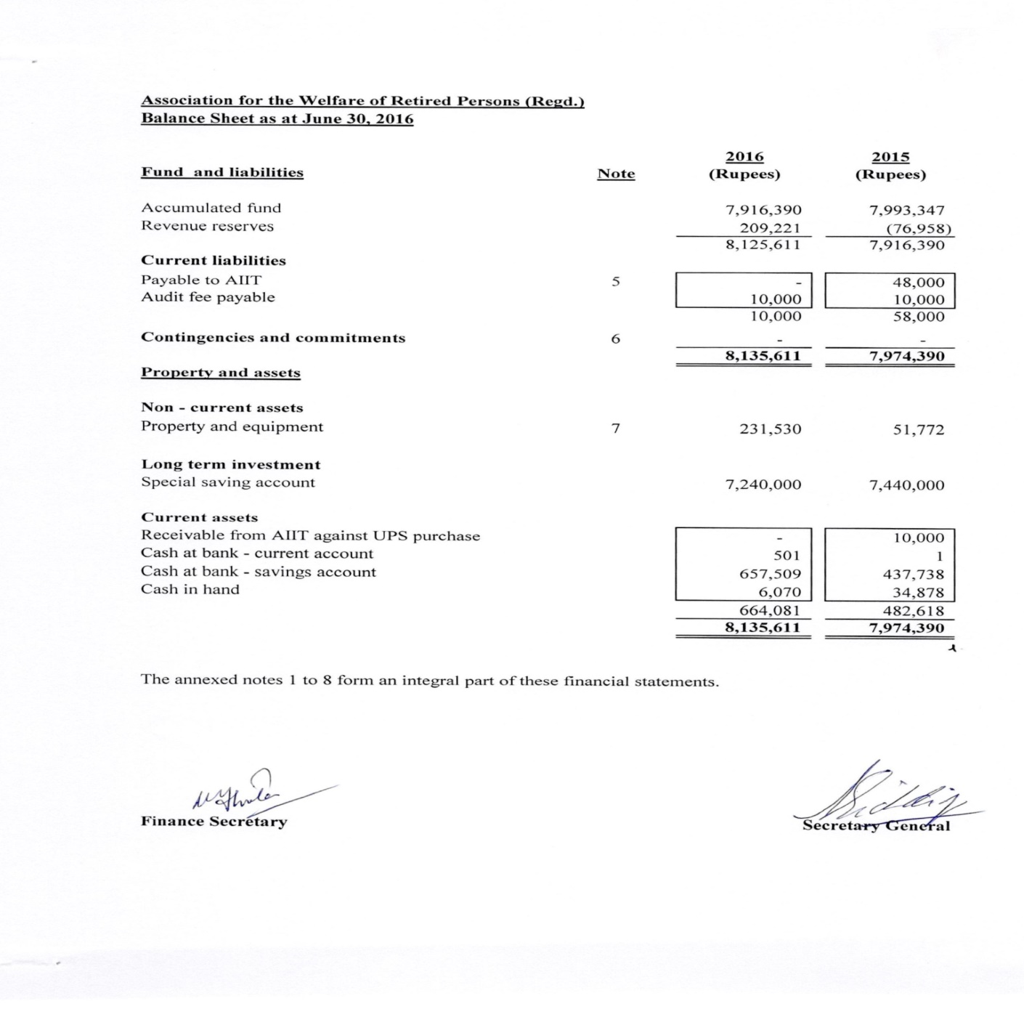
BALANCE SHEET
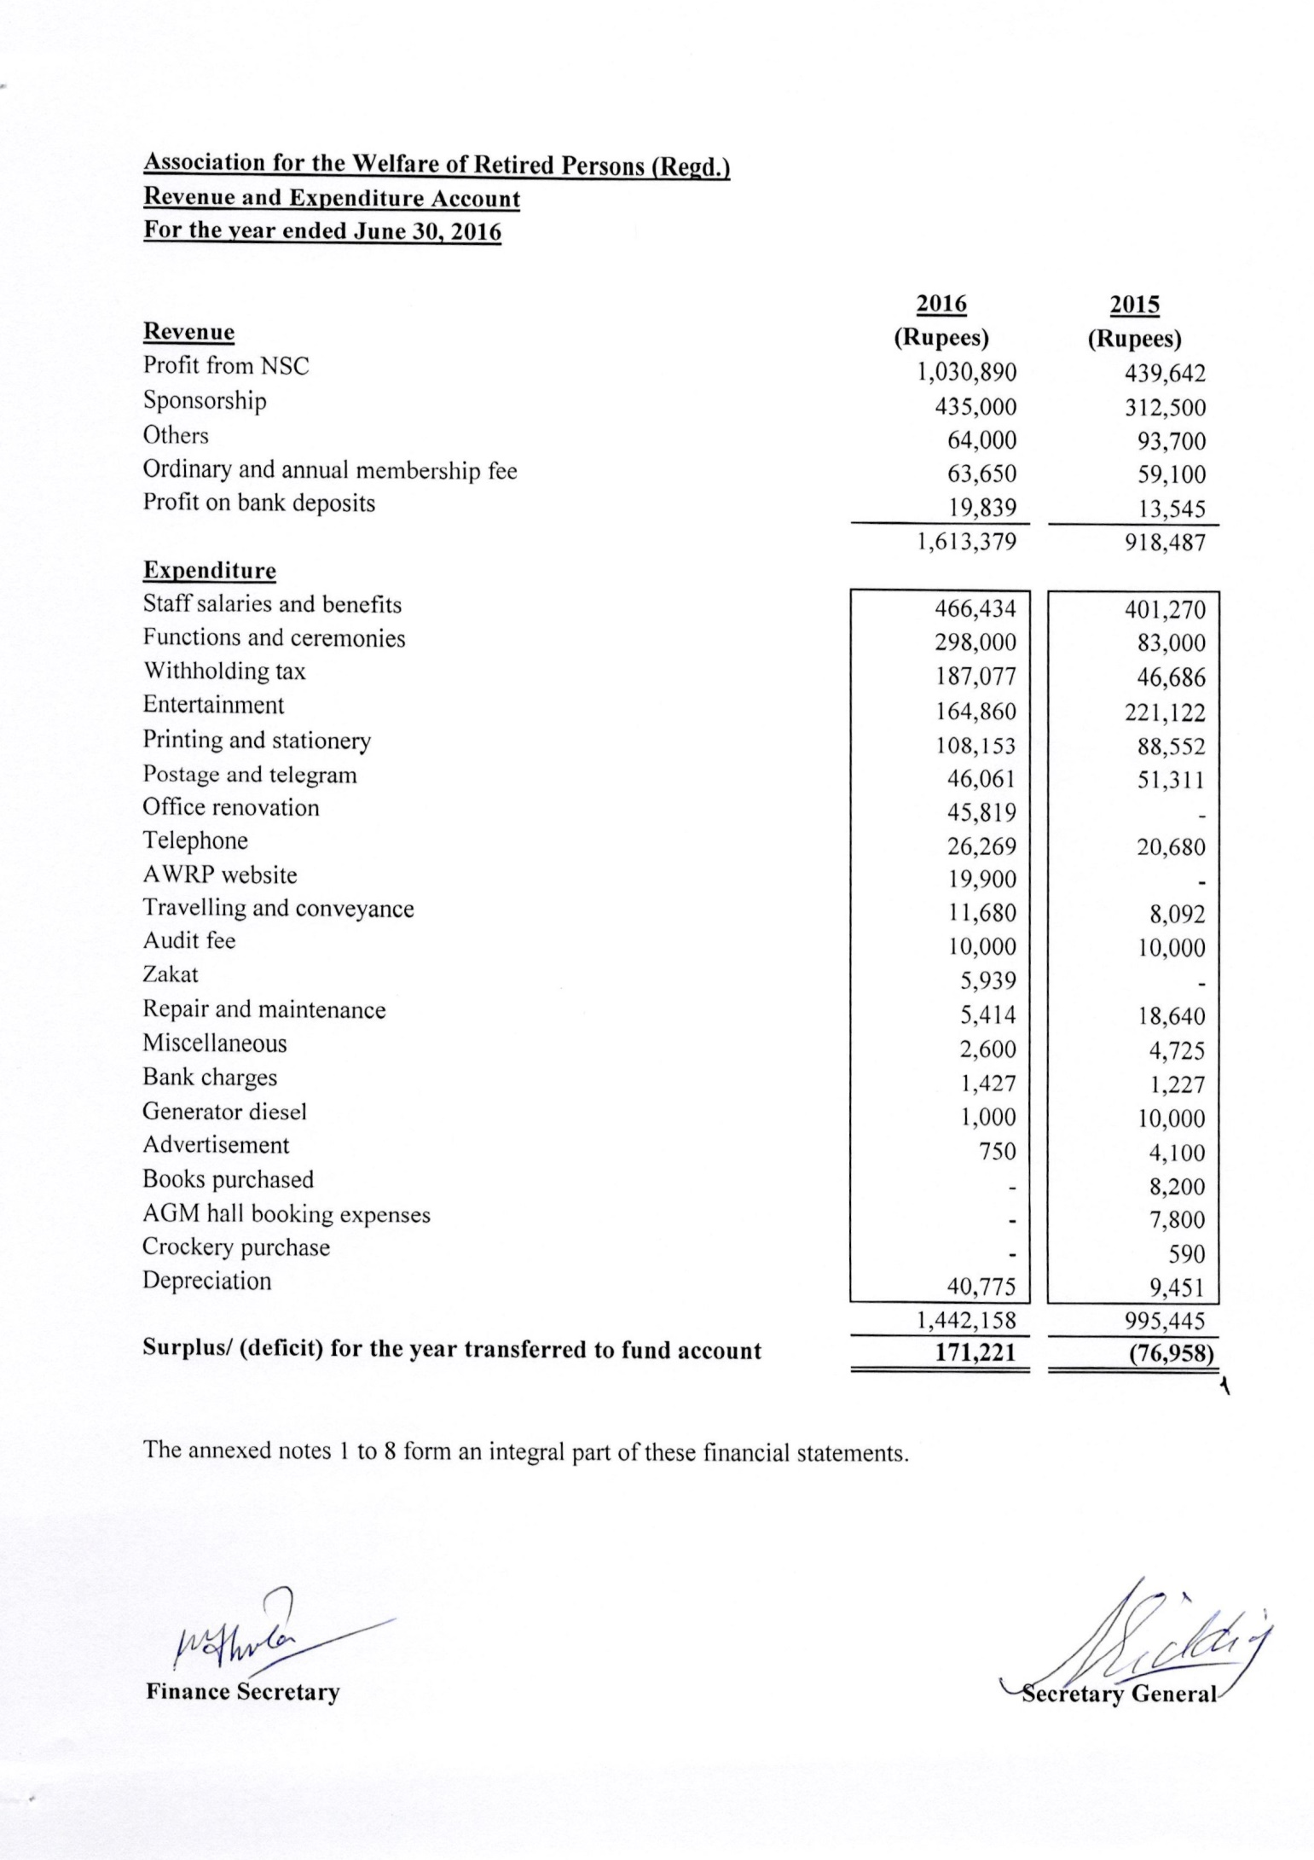
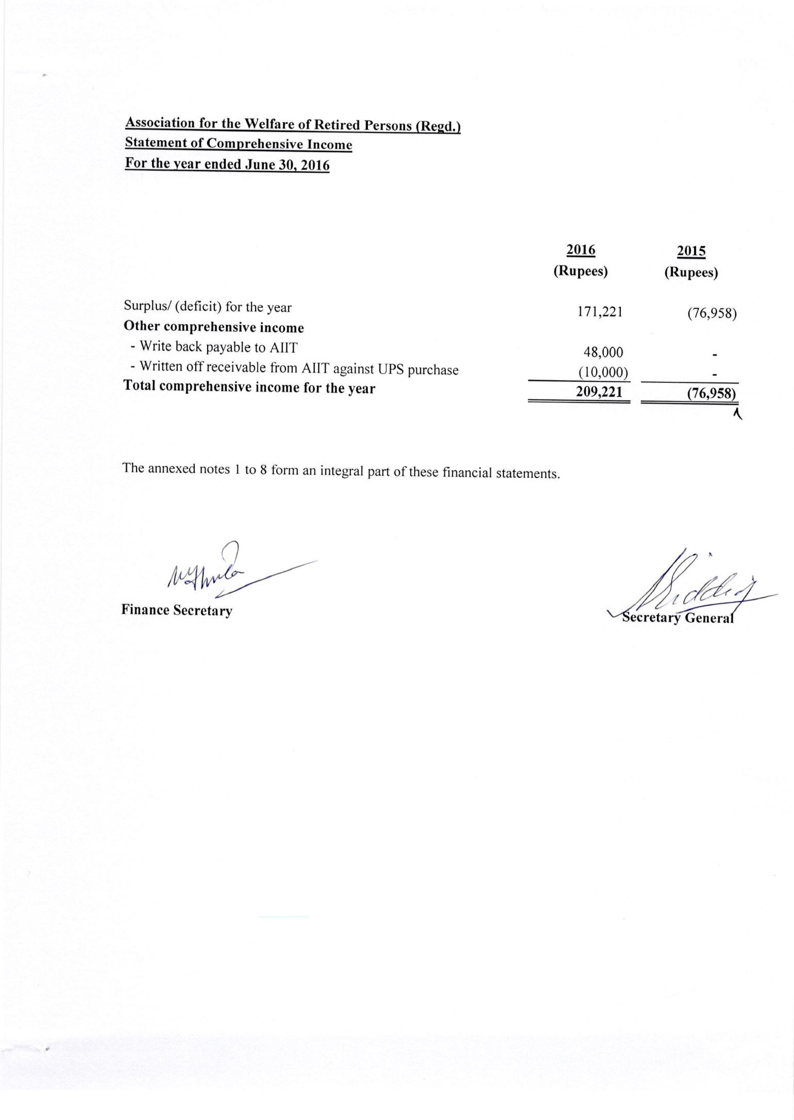
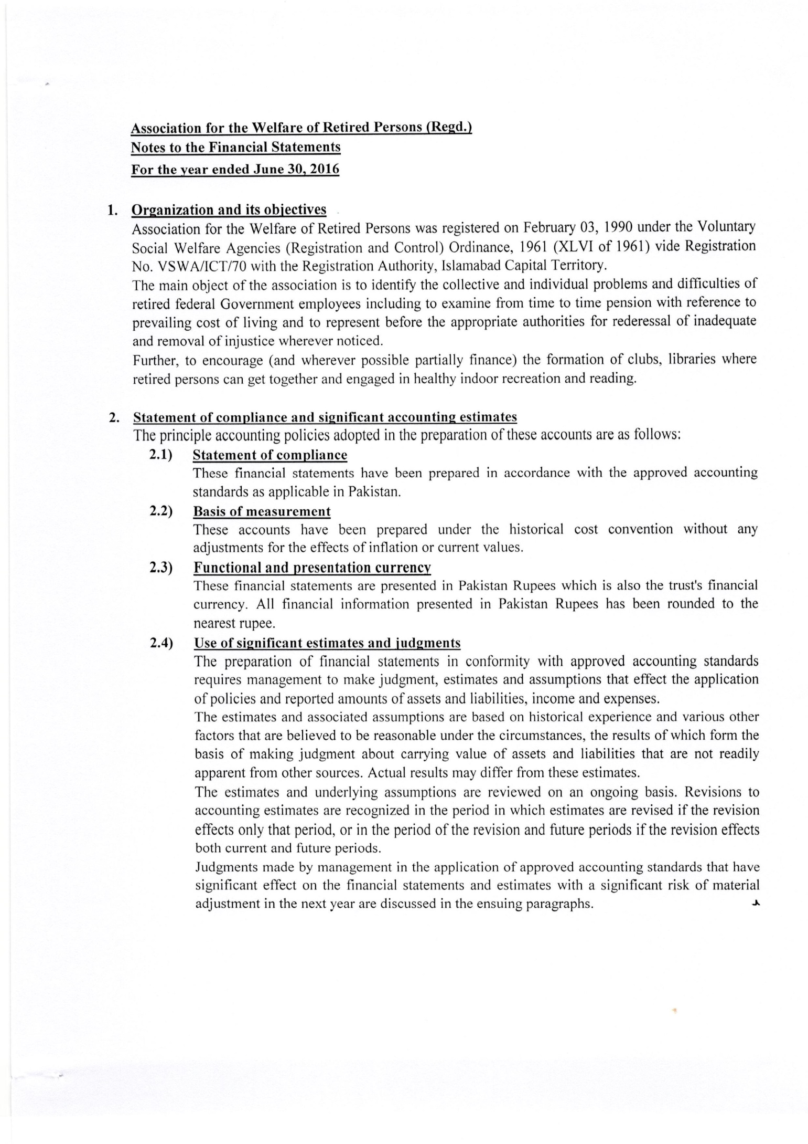
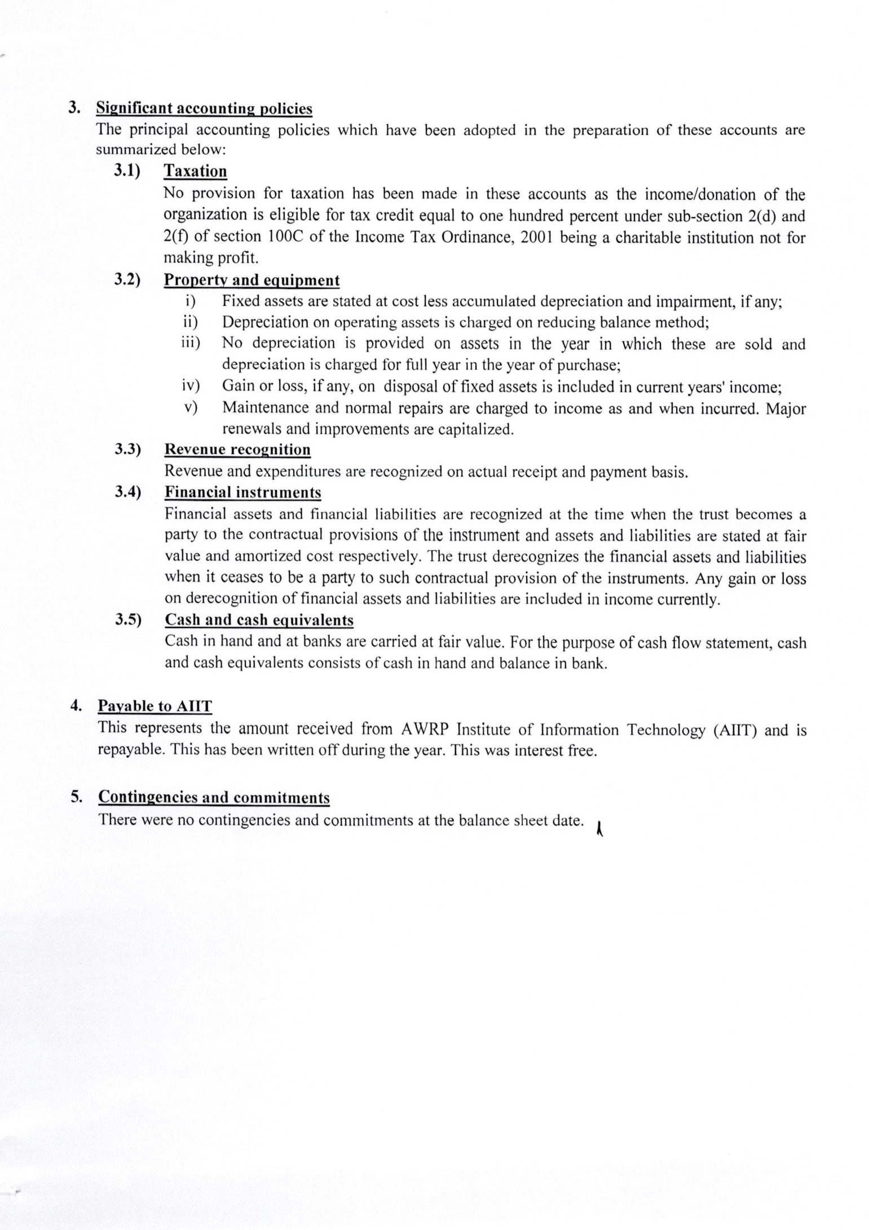
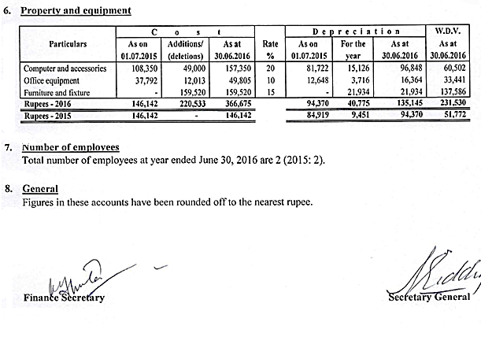

Nomination of Masoom Akhtar & Co. Auditors

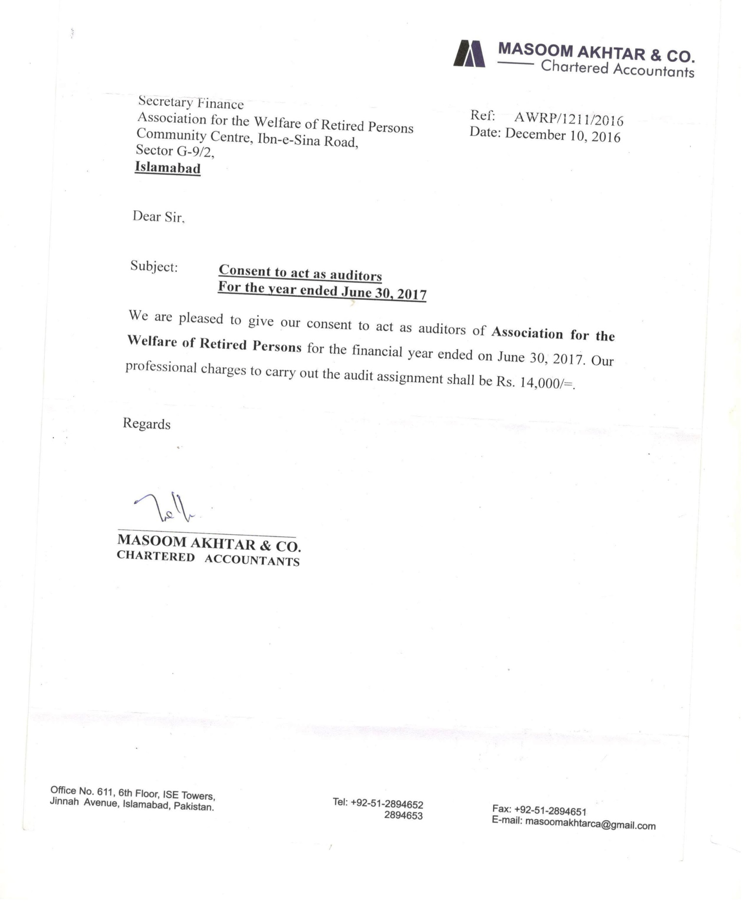
PROPOSED BUDGET AWRP 2017-18
Particulars | Actual for 2015-16  (Rupees) | Proposed for 2017-18  (Rupees)
INCOME | Actual for 2015-16  (Rupees) | Proposed for 2017-18  (Rupees)
Annual Membership Fee | 63,650 | 75,000
Sponsorship Income | 435,000 | 450,000
Profit on Bank Deposits | 19,839 | 20,000
Profit From NSC  (Profit after six months) | 1,030,890 | 1,50,000
Other Income | 64,000 | 70,000
Total | 1,613,379 | 1,765,000
EXPENDITURE
Salary and Wages | 466,434 | 500,000
Books | - | 2,000
New Projects (Purchase of Blood testing machine for AWRP Office) | - | 200,000
Telephone | 26,269 | 30,000
Printing and Stationary | 108,153 | 110,000
Entertainment | 164,860 | 200,000
Function and Ceremonies | 298,000 | 300,000
AGM Hall Booking | - | 10,000
Withholding tax | 187,077 | 190,000
Audit Fee | 10000 | 14,000
Advertisement | 750 | 20,000
Crockery | - | 10,000
Bank Charges | 1427 | 2,000
Postage and Telegram | 46,061 | 50,000
Repairing and Maintenance | 5,414 | 7,000
Travelling and conveyance | 11,680 | 12,000
Website Expenses | 19,900 | 20,000
Misc. | 2600 | 3,000
Total | 1,348,625 | 1,680,000
Saving (Income-Expenditure) | 2,64,754 | 85000

RESOLUTION

APPONINTMENT OF PATRON
Whereas article 8 sub-clause(b)8 of the Constitution authorises the General Body to “appoint and approve a renowned person as the Patron of the Association on the recommendation Executive Committee.” who in its view would be helpful in promoting the objectives of the Association;
Resolved that the Executive Committee of AWRP urges the General Body to appoint Mr. M. Abdullah Yusuf as the Patron of AWRP.

EXECUTIVE COMMITTEE ELECTION 2015-16

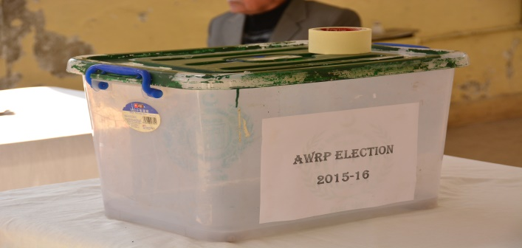 | 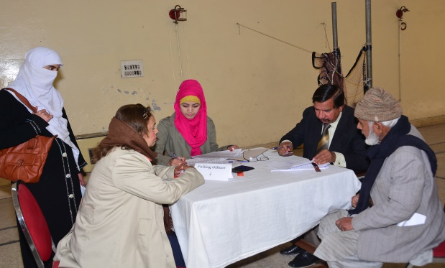
Ballot Box | Ballot papers being issued
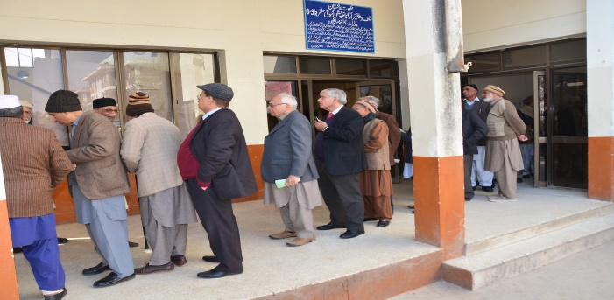 | 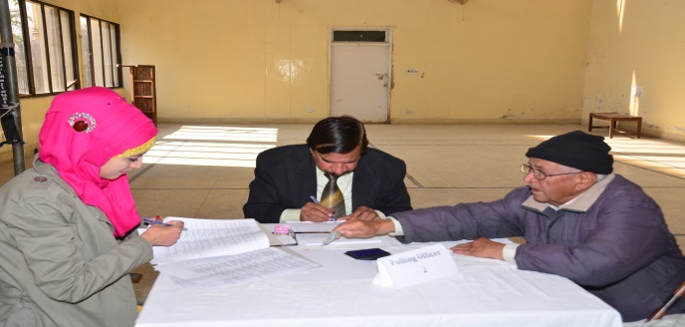
Members waiting to cast vote | Members marking ballot paper
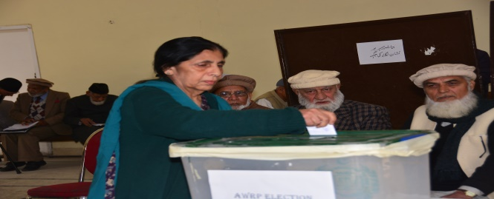 | 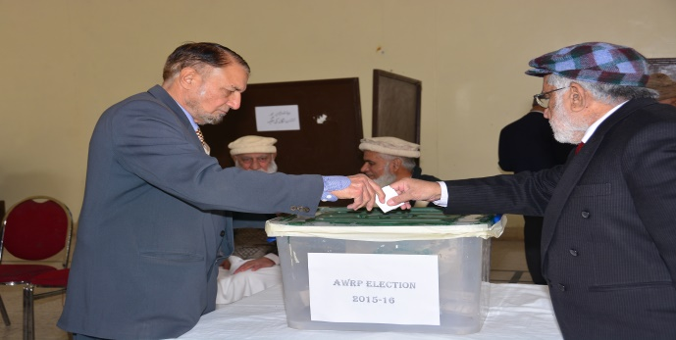
Female Member casting vote | Male Members casting vote

BOOK POST/PRINTED MATTER
Association for the Welfare of Retired Persons
(a national boday of retired civilian employees of the federal government)
NEW VISTAS
Ist. Quarter 2017
Regd. No ID-269

TO. _______________________________________________

Stamp
_______________________________________________
_______________________________________________

If undelivered, please return to.
Association for the Welfare of Retired Persons (AWRP)
Community Centre, Ibn- e -Sina Road, G-9/2, Islamabad.
Telephone. 051-2256282

